NSSP Weekly Report

NSSP Week Ending 09/08/2017 POC: Alan Davis

NSSP Items This Week

The NSSP IT project operates with two primary sub-projects for tracking purposes: (1) Development and (2) Technical Assistance. The Onboarding project is a sub-project of Technical Assistance. Several charts depicting the weekly status of these projects, as well as glossary of chart terms, can be found in the Appendix.

Development Sprint Chart
In order to perform Earned Value Management, the BioSense/NSSP IT project team will begin estimating sprints in hours and not sprint points. Earned value project/performance management (EVPM) is a project management technique for measuring project performance and progress in an objective manner. In this version of a sprint burn down chart the red line going down represents the value earned (work completed against the estimate) and the green line represents the hours worked.
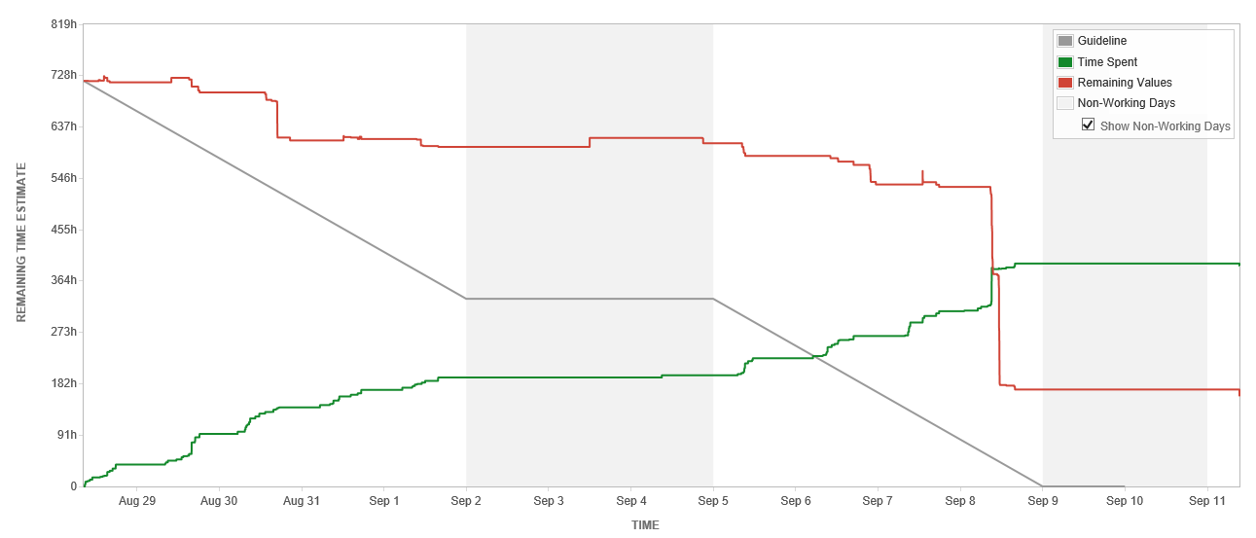

Development Velocity Summary – Last 5 Sprints
Sprint and Start Date | Sprint Items | Sprint Backlog Total Time (hours)  Initial + Changes | Scope Changes  (hours) | Sprint Velocity  Time (hours) Completed | Time (hours)  Unfinished
Sprint 71, 08/28/17 | 48 | 785 | 66 | 527 | 258
Sprint 70, 08/14/17 | 59 | 666 | 6 | 481 | 183
Sprint 69, 07/31/17 | 57 | 910 | (1) | 624 | 286
Sprint 68, 07/17/17 | 61 | 833 | 44 | 676 | 156
Sprint 67, 07/03/17 | 48 | 826 | 32 | 499 | 327
Note: Negative scope hours are reflective of items taken from the sprint over a two week period (sprint start and end).

Description of Current Key Activities
In this section we will summarize the key activities in-progress for the week. This section will provide a high-level overview of the main areas of focus for each key activity. The activities are listed in alphabetical order.
- AMC Active Directory: The purpose of this activity is to complete the work necessary for single-sign on username and password across the tools/services on the NSSP BioSense Platform. When the work is complete users will have one username and password to control access to AMC, ESSENCE, RStudio, SAS, Adminer, and the BioTerminal. Currently, there are different username/passwords for AMC and RStudio. The expected release date of the new authentication process for AMC has been pushed back to 9/13/17 due to an issue found during Staging testing.. The CIDROC ORR was completed on August 23, 2017. The Enterprise Governance EPLC meeting was held on on September 6, 2017. The activities described below are part of the tasks accomplished and planned to achieve the deadline.
- Legacy Data Migration: The purpose of this activity is to migrate data from the old BioSense platform databases to ESSENCE. There are several steps to do the Legacy data migration process including developing base code for PHINMS and SFTP versions, collecting special requirements from sites, modifying code as needed, communications, QA, and data processing.
- Master Facility Table User Interface Requirements: The purpose of this activity is to finalize the initial requirements for the Master Facility Table proposed user interface. Development for the new UI is projected for after the Active Directory implementation is complete.
- Data Sharing Reports Requirements: In August, the first requirements session for revisiting the BioSense Platform data sharing report. This is the first step in recreating a data sharing report off of the Access and Management Center’s data access rules.

Key Accomplishments (across the project)
Category | Key Accomplishments and Plans
Requirements | - Access Management Center (AMC)  - Updated test scripts to include steps to test ESSENCE access on the backend.  - Updated test scripts to test for known defects.  - Active Directory (AD)  - Performed testing of AMC New User Status Defect.  - Performed testing of ESSENCE data rules duplication issue
System Development & Maintenance | - Server Operations & Maintenance  - Perform additional work on the implementation of Environmental Manager Reporting  - Initiate customization of canned EM reports.  - Initiate definition classification groups for EM.  - Active Directory (AD)  - Ran the AMC matching process on list of AD users.  - Resolved AMC issue to show ‘new’ status appropriately on ‘Manage Users’ screen.  - Investigated issue with syncing rules from AMC to ESSENCE.  - Other  - Supported knowledge transfer documentation for reports.  - Finalized a draft schema and RAW TABLE for ASPR DMAT Data in DataMart.  - Supported initiation of ASPR dataflow into ESSENCE.  - Moved all contractor emails from TO or CC line to BCC line on ESSENCE and AMC.
Data Onboarding | - New Sites  - Facilitated Onboarding kick-off call.  - Began Onboarding for one new facility.  - MFT Updates  - Completed one site’s Umbrella Binning.  - Performed MFT updates for one site.
Technical Support | N/A
Data Analytics | - Legacy  - Sent QA summary for two sites in Staging.  - Sent QA summary for two sites in Production.  - Updated the legacy conversion roadmap.  - Moved one site’s data into Production.  - Moved one site’s data into ESSENCE.  - Submitted four site’s data for SI review.  - Reprocessed legacy records for facilities that were not available at legacy runtime for two sites.  - Removed excess data records for one site.  - Data Quality  - Debugged legacy issue found in two site’s data related to the facilities that failed operational crosswalk.  - Debugged legacy issue found in three site’s data related to C_Patient_Age and C_Patient_Age_Source.  - QA tested the legacy patching for the C_Patient_Class change request.  - Completed CCQV Query Log investigation.
Training and Communication | - Compiled and presented Service Desk dashboard to CDC.  - Completed draft of Service Desk SOP.  - Sent out communication regarding delayed date for AD deployment.

Plans for Next Week (across the project)
Category | Key Accomplishments and Plans
Requirements | - Active Directory (AD)  - Perform last minute defect testing for the Active Directory deployment.  - Perform a partial regression test for the Active Directory deployment.  - MFT  - Finalize functional and UI requirements for the MFT Facility Administration Tool.  - Develop an implementation plan for the MFT Facility Administration tool.
System Development & Maintenance | - Server Operations and Maintenance  - Update stored procedures in Master Facility Processing.  - AMC Active Directory  - Update AMC AD and Normal AMC email language for Production.  - Other  - Finalize ‘Lights On’ and ‘DataMart Dashboard’ reports SOP.  - Compile a daily report for ASPR to a broader group, in addition to hourly alerts.  - Update View off of the reporting DB with column names exceeding 32 characters in length.
Data Onboarding | - Feed Issues  - Resolve issue with Minnesota Mirth data parsing CSV coming out of VARCHAR incorrectly.  - Deploy Minnesota mapping changes in Staging.  - Master Facility Table  - Clean up WA Maintenance MFT.  - Other  - Facilitate DQ Committee Call.
Technical Support | - Internal  - Perform KT activities with requirements team member regarding service desk duties.  - Perform KT activities with new SDA team member.
Data Analytics | - Legacy  - Send out legacy communications to six sites.  - Produce weekly Legacy Conversion Status One Pager.  - Perform patching on six site’s data.  - Other  - Update the Reporting SOP to include the issue tracking process.
Training & Communication | - N/A

New/Significant Project Issues/Risks/Scope Changes for Current Sprint
Type | ID | Description | Mitigation/Action Taken | Status | Owner
Risk | R012 | Amazon infrastructure issues may affect BioSense Platform infrastructure. | Monitor Amazon performance and prioritize and respond to issues as determined by the project team. | Monitor | Mike Coletta
Risk | R013 | The development, testing, and staging environment AMC applications are not independent systems. Existing connections between each may lead to issues when new development is implemented | The team will work to identify a long term solution to separate the applications (AMC & ESSENCE) in each environment. In the short term, they will create and adhere to SOPs and checklists for releasing new builds in each environment | Monitor | Mike Coletta
Risk | R014 | There is a delay in Production AMC when AMC writes data access rules to ESSENCE. This can lead to rule duplication and rules deletion. | The team will work to investigate the cause of this delay. In the long term, they will look into removing edit capabilities within the ESSENCE application. | Monitor | Mike Coletta

System Maintenance, Updates and Outages
Date(s) Time(s) of Outages/Updates/Patches | Estimated Downtime | Reason | Expected or Unexpected
N/A
Production ESSENCE Restarts
Week |  | Number of ESSENCE Restarts
09/04/17 – 09/08/17 |  | 9

Requirements Status and Agile Development Activities (Sub-task 2.3.2 & Sub-task 2.3.6)
 | Date | Last Week's Activities | %  Complete | Upcoming Activities
Data Flow | 08/26/2017 | Completed C_Patient_Class testing in staging and initiated in production. | 90% | Expected to complete in the following week.
Access & Management Center | 08/26/2017 | Active Directory Staging almost complete | 80% | Complete regression testing and prepare for AD deployment in production.
Master Facility Table | 08/26/2017 | No activities last week. | 50% | Continue updating requirements documentation.
Reporting | 08/26/2017 | Met with CDC to discuss time/date in databases and gathered requirements to create views to help with time/data and joins | 25% | Complete views.

Community Enhancement Requests
Enhancement Type | Key | Summary | Status | Created | Updated
General Feedback | NTA-1443 | Data provider request to see DOB included in chief complain field for work flow purposes | Open | 08/15/2017 | 08/22/2017
General Feedback | NTA-1498 | ESSENCE myAlert Subscriptions – identify date of initial subscription and subscribed user | Open | 08/24/2017 | 08/29/2017
Feature/Improvement | NTA-1525 | Add queries to myESSENCE dashboards directly from the Query Manager. | Open | 08/30/2017 | 08/31/2017
General Feedback | NTA -1533 | Incorrect concatenation of data field Visit_Type_Code. | Open | 08/31/2017 | 09/01/2017

Appendix

Status of This Week’s Technical Assistance Requests

In order to monitor the quality of service provided to external users, the BioSense/NSSP IT project team measures the number of technical assistance requests received in a given week against the number of requests resolved. In this chart you can see the breakdown by issue type of the received requests, as well as the status of the requests.

Status of This Week’s Development Requests

In order to track the progress of the sprint, the BioSense/NSSP IT project team measures the number of development tickets created and resolved on a weekly basis, as well as the overall number of open tickets left to be resolved. In this chart you can see the breakdown by ticket issue type and the status of the tickets.

Development and Technical Assistance Tickets for Current Sprint
The below Chart displays the total number of tickets created this week for the functional development of the current sprint. The chart breaks down the tickets based on the Priority Rubric they were created under.

Status of This Week’s Onboarding Requests

In order to monitor the onboarding progress of new sites, the BioSense/NSSP IT project team measures the number of onboarding tickets created and resolved on a weekly basis, as well as the overall number of open tickets left to be resolved. This information allows the project team to quickly analyze pain points and work to resolve them.

Chart Glossary
Term | Definition
Technical Assistance JIRA Ticket Types
Feat. /Func. Suggestion | A feature or functionality suggested by users/stakeholders.
Onboarding | An onboarding-related technical item.
Processing | A request/item that relates to data processing.
Questions | Any questions for the technical assistance team, e.g. HL7 mapping guide.
Tech. Issue - Backend | A technical issue with the backend of the BioSense system.
Tech. Issue - Frontend | A technical issue with the frontend of the BioSense system.
User Accnt/Access | A user account or access request, e.g. R Studio access.
Other | Other technical requests, e.g. request for new certificates.
Development JIRA Ticket Types
Task/Sub-Task | A development-related issue or request.
Improvement | A suggested change to the system.
New Feature/Function | A suggested new feature to the system.
Bug | A development-related issue or defect.
Status
Open | The item/ticket is in queue.
Active | The item/ticket is in progress.
Inactive | Work on the item/ticket has started, but is on hold for a particular reason.
Waiting for Customer/Support | The item/ticket is being worked on and is waiting on a reply from the customer or support.
Resolved | The item/ticket is done, but needs to be reviewed.
Complete | The item/ticket is done and has been reviewed.
Re-opened | After being resolved or complete, the ticket is re-opened for a particular reason.
Priority Rubric | The development and technical assistance tickets grouped by BioSense Platform functional area
Other Items
BTA | BioSense Technical Assistance. Item/tickets related to technical assistance and coming through the Help Desk.
BA | BioSense Agile. Items/tickets related to development or feature requests or backlog.
Agile | Software development methodology to create requirements and solutions.

