NSSP Weekly Report

NSSP Week Ending 08/25/2017 POC: Alan Davis

NSSP Items This Week

The NSSP IT project operates with two primary sub-projects for tracking purposes: (1) Development and (2) Technical Assistance. The Onboarding project is a sub-project of Technical Assistance. Several charts depicting the weekly status of these projects, as well as glossary of chart terms, can be found in the Appendix.

Development Sprint Chart
In order to perform Earned Value Management, the BioSense/NSSP IT project team will begin estimating sprints in hours and not sprint points. Earned value project/performance management (EVPM) is a project management technique for measuring project performance and progress in an objective manner. In this version of a sprint burn down chart the red line going down represents the value earned (work completed against the estimate) and the green line represents the hours worked.
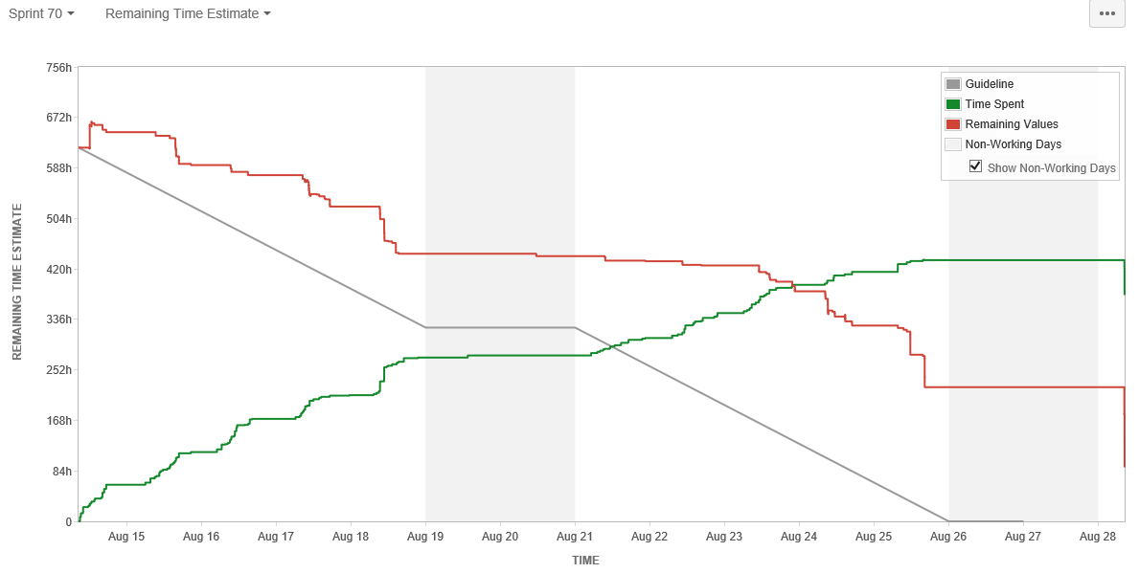

Development Velocity Summary – Last 5 Sprints
Sprint and Start Date | Sprint Items | Sprint Backlog Total Time (hours)  Initial + Changes | Scope Changes  (hours) | Sprint Velocity  Time (hours) Completed | Time (hours)  Unfinished
Sprint 70, 08/14/17 | 59 | 666 | 6 | 481 | 183
Sprint 69, 07/31/17 | 57 | 910 | (1) | 624 | 286
Sprint 68, 07/17/17 | 61 | 833 | 44 | 676 | 156
Sprint 67, 07/03/17 | 48 | 826 | 32 | 499 | 327
Sprint 66, 06/19/17 | 68 | 979 | 100 | 651 | 328
Note: Negative scope hours are reflective of items taken from the sprint over a two week period (sprint start and end).

Description of Current Key Activities
In this section we will summarize the key activities in-progress for the week. This section will provide a high-level overview of the main areas of focus for each key activity. The activities are listed in alphabetical order.
- AMC Active Directory: The purpose of this activity is to complete the work necessary for single-sign on username and password across the tools/services on the NSSP BioSense Platform. When the work is complete users will have one username and password to control access to AMC, ESSENCE, RStudio, SAS, Adminer, and the BioTerminal. Currently, there are different username/passwords for AMC and RStudio. The expected release date of the new authentication process for AMC is 9/7/17. The CIDROC ORR was completed on August 23, 2017. The next milestone is the Enterprise Governance EPLC meeting on September 6, 2017. The activities described below are part of the tasks accomplished and planned to achieve the deadline.
- Legacy Data Migration: The purpose of this activity is to migrate data from the old BioSense platform databases to ESSENCE. There are several steps to do the Legacy data migration process including developing base code for PHINMS and SFTP versions, collecting special requirements from sites, modifying code as needed, communications, QA, and data processing.
- Master Facility Table User Interface Requirements: The purpose of this activity is to finalize the initial requirements for the Master Facility Table proposed user interface. Development for the new UI is projected for after the Active Directory implementation is complete.
- Data Sharing Reports Requirements: In August, the first requirements session for revisiting the BioSense Platform data sharing report. This is the first step in recreating a data sharing report off of the Access and Management Center’s data access rules.

Key Accomplishments (across the project)
Category | Key Accomplishments and Plans
Requirements | - Access Management Center (AMC)  - Finalized updated AMC Quick Start Guide to include changes caused by Active Directory.  - Active Directory (AD)  - Performed testing of Active Directory functionality in Staging environment.  - Performed regression testing of AMC in Staging environment.
System Development & Maintenance | - Server Operations & Maintenance  - Troubleshot incidents with new SAS install.  - Completed remediation of SAS deployment Manager Bug;  - Completed application of SAS Licenses.  - Investigated and resolved the issue regarding two VA servers sharing the same library name.  - Active Directory (AD)  - Developed and implemented automatic tool for emails to be sent after AD implementation.  - Deployed AD in Staging environment.  - Resolved ticket BA-3802 “AMC AD: Deploy Staging Build (ON AUG 23 8AM EDT)”.  - Resolved ticket BA-3782 “AMC AD: Deploy the Conversion”.  - Resolved ticket BA-3858 “Data Access Rule Add Users Table should not display inactive or OA users”.  - Other  - Resolved ticket BA-3723 “Staging AMC Domain Controller Testing”.  - Created a high level plan for the AMC Staging deployment and coordinated deployment.  - Finalized SQL API documentation and submitted for review.  - Investigated missing Master Profile changes on Staging and applied the changed in Production to fix the issue.
Data Onboarding | - New Sites  - Sent Completeness Report to site for review.  - Restarted site’s service after removing them from the SKIP command.  - MFT Updates  - Feed Issues  - Resolved two site’s C_FacType_Patient_Class issue in the hl7 code.  - Communicated to data feed the drops on the Lights on Report for three sites.  - Resolved data flow issues for two sites.  - Other  - Resolved significant number of breached Onboarding tickets.  - Distributed Onboarding JIRA tickets to Onboarding to team to be resolved.  - Compiled Onboarding metrics for Support Ticket Meeting.  - Created a Facilities by FacilityType Report in Tableau to show sites with excess amounts of facilities that slow the overall process down.
Technical Support | - Internal  - Performed KT with requirements analyst on service desk duties.  - Investigated issues surrounding SAS DQ database.  - Investigated issues surrounding Reporting data snapshots and formulated a plan to address them.
Data Analytics | - Legacy  - Produced Weekly Legacy Conversion Status One Pager.  - Sent the summary of sites that need reminders to perform a final review of their data.  - Sent the QA summary for site’s PHINMS data.  - Updated the roadmap for legacy conversion.  - Completed conversions for of the available sites.  - Submitted one site’s PHINMS data to SI for review for production conversion.  - Submitted three sites; sFTP data for review in the Staging environment.  - Conducted QA on one site’s data in Production environment.  - Conducted QA on three site’s data in Staging environment.  - Data Quality  - Finalized the C_Patient_Class requirements.  - Completed development ticket BA-3761 “C Patient Class: 1.1 Develop and test SQL data processing procedures”.  - Completed development ticket BA-3762 “C Patient Class: 1.2 Plan and deploy SQL data processing procedures”.  - Completed development ticket BA-3763 “C Patient Class: 2.1 Develop and test the patch process”.  - Completed development ticket BA-3764 “C Patient Class: 2.2 Plan and deploy patch”.  - Other  - Updated the legacy communications email template.  - Sent out the UAT opportunity communications.  - Produced a draft of reporting roadmap.
Training and Communication | - JIRA Service Desk  - Retired STA project.  - Created ADM dashboards for four sites.  - Created dashboard for NSSP Service Desk.  - Other  - Created list of AMC users with ESSENCE issues.  - Submitted spreadsheet of AD users’ resolutions to ICF for review.  - Submitted data deletion form to CDC.  - Compiled list of data deletions.  - Communications  - Sent out communications regarding DQ reports.  - Conducted Community Call and distributed presentation slides.  - Created next communications for Active Directory User Migration.  - Cleared language for community call reminder.  - Submitted blurb for NSSP newsletter for review by CDC.

Plans for Next Week (across the project)
Category | Key Accomplishments and Plans
Requirements | - Access Management Center (AMC)  - Submit AMC Quick Start Guide for review/clearance.  - Develop requirements and wireframes for dynamic button.  - Revisit and potentially revise functionality of Reports table site filter.  - Active Directory (AD)  - Complete testing of Active Directory functionality in Staging environment.  - Complete regression testing in staging environment.  - Investigate and retest bugs discovered during testing.  - Prepare for production deployment.  - Other  - Compile and submit JIRA Development Summary, Call Volumes Report, and Monthly report to CDC.  - Knowledge transfer for reporting documentation among team members.
System Development & Maintenance | - Other  - Finalize SOP for SAS users.  - Create view around Lights on and Datamart reports for the data to be available in SAS.  - Run an updated user list out of Production AMC.  - Update views off of the Reporting DB with column names more than 32 characters.  - Update Apache in Production to fix the PIV issue.  - Update all usernames in SAS on morning of 09/07.
Data Onboarding | - New Sites  - Follow up with Fall Onboarding sites.  - Master Facility Table  - Execute requested MFT updates.  - Review MFT additions and Completeness Validation Reports with site admins.  - Other  - Develop Onboarding Data Validation standards.  - Collaborate with Technical Staff to resolve ESSENCE login issue.  - Monitor ESSENCE for abnormalities and perform further investigation into the Completeness Reports.  - Create a draft schema and RAW TABLE for the ASPR DMAT Data in DATAMART.  - Update stored procedures in Master Facility Processing Code.  - Develop a data deletion process and tracking method.
Technical Support | - Internal  - Perform KT with new Reporting team member.
Data Analytics | - Legacy  - Send out communications to six legacy sites.  - Data Quality  - Perform patching on seven site’s sFTP data.  - Conduct CCQV query log investigation.  - Complete development ticket BA-3765 “C Patient Class: 3.1 Develop and test the code”.  - Complete development ticket BA-3766 “C Patient Class: 4.1 Develop and test the patch for PHINCONV_Archive databases”.  - Complete development ticket BA-3767 “C Patient Class: 4.2 Plan and deploy patch”.  - Execute Minnesota Data Processing fix.
Training & Communication | - Send out Active Directory Deployment communication reminder

New/Significant Project Issues/Risks/Scope Changes for Current Sprint
Type | ID | Description | Mitigation/Action Taken | Status | Owner
Risk | R012 | Amazon infrastructure issues may affect BioSense Platform infrastructure. | Monitor Amazon performance and prioritize and respond to issues as determined by the project team. | Monitor | Mike Coletta
Risk | R013 | The development, testing, and staging environment AMC applications are not independent systems. Existing connections between each may lead to issues when new development is implemented | The team will work to identify a long term solution to separate the applications (AMC & ESSENCE) in each environment. In the short term, they will create and adhere to SOPs and checklists for releasing new builds in each environment | Monitor | Mike Coletta

System Maintenance, Updates and Outages
Date(s) Time(s) of Outages/Updates/Patches | Estimated Downtime | Reason | Expected or Unexpected
N/A
Production ESSENCE Restarts
Week |  | Number of ESSENCE Restarts
08/18/17 – 08/25/17 |  | 6

Requirements Status and Agile Development Activities (Sub-task 2.3.2 & Sub-task 2.3.6)
 | Date | Last Week's Activities | %  Complete | Upcoming Activities
Data Flow | 08/26/2017 | Completed C_Patient_Class testing in staging and initiated in production. | 90% | Expected to complete in the following week.
Access & Management Center | 08/26/2017 | Active Directory Staging almost complete | 80% | Complete regression testing and prepare for AD deployment in production.
Master Facility Table | 08/26/2017 | No activities last week. | 50% | Continue updating requirements documentation.
Reporting | 08/26/2017 | Met with CDC to discuss time/date in databases and gathered requirements to create views to help with time/data and joins | 25% | Complete views.

Community Enhancement Requests
Enhancement Type | Key | Summary | Status | Created | Updated
General Feedback | NTA-1443 | Data provider request to see DOB included in chief complain field for work flow purposes | Open | 08/15/2017 | 08/22/2017
New Feature/Improvement | NTA-1506 | ESSENCE Request - Display month and days on weekly aggregate chart | Open | 08/25/2017 | 08/25/2017
General Feedback | NTA-1498 | ESSENCE myAlert Subscriptions – identify date of initial subscription and subscribed user | Open | 08/24/2017 | 08/24/2017

Appendix

Status of This Week’s Technical Assistance Requests

In order to monitor the quality of service provided to external users, the BioSense/NSSP IT project team measures the number of technical assistance requests received in a given week against the number of requests resolved. In this chart you can see the breakdown by issue type of the received requests, as well as the status of the requests.

Status of This Week’s Development Requests

In order to track the progress of the sprint, the BioSense/NSSP IT project team measures the number of development tickets created and resolved on a weekly basis, as well as the overall number of open tickets left to be resolved. In this chart you can see the breakdown by ticket issue type and the status of the tickets.

Development and Technical Assistance Tickets for Current Sprint
The below Chart displays the total number of tickets created this week for the functional development of the current sprint. The chart breaks down the tickets based on the Priority Rubric they were created under.

Status of This Week’s Onboarding Requests

In order to monitor the onboarding progress of new sites, the BioSense/NSSP IT project team measures the number of onboarding tickets created and resolved on a weekly basis, as well as the overall number of open tickets left to be resolved. This information allows the project team to quickly analyze pain points and work to resolve them.

Chart Glossary
Term | Definition
Technical Assistance JIRA Ticket Types
Feat. /Func. Suggestion | A feature or functionality suggested by users/stakeholders.
Onboarding | An onboarding-related technical item.
Processing | A request/item that relates to data processing.
Questions | Any questions for the technical assistance team, e.g. HL7 mapping guide.
Tech. Issue - Backend | A technical issue with the backend of the BioSense system.
Tech. Issue - Frontend | A technical issue with the frontend of the BioSense system.
User Accnt/Access | A user account or access request, e.g. R Studio access.
Other | Other technical requests, e.g. request for new certificates.
Development JIRA Ticket Types
Task/Sub-Task | A development-related issue or request.
Improvement | A suggested change to the system.
New Feature/Function | A suggested new feature to the system.
Bug | A development-related issue or defect.
Status
Open | The item/ticket is in queue.
Active | The item/ticket is in progress.
Inactive | Work on the item/ticket has started, but is on hold for a particular reason.
Waiting for Customer/Support | The item/ticket is being worked on and is waiting on a reply from the customer or support.
Resolved | The item/ticket is done, but needs to be reviewed.
Complete | The item/ticket is done and has been reviewed.
Re-opened | After being resolved or complete, the ticket is re-opened for a particular reason.
Priority Rubric | The development and technical assistance tickets grouped by BioSense Platform functional area
Other Items
BTA | BioSense Technical Assistance. Item/tickets related to technical assistance and coming through the Help Desk.
BA | BioSense Agile. Items/tickets related to development or feature requests or backlog.
Agile | Software development methodology to create requirements and solutions.

