NSSP Weekly Report

NSSP Week Ending 07/07/2017 POC: Alan Davis

NSSP Items This Week

The NSSP IT project operates with two primary sub-projects for tracking purposes: (1) Development and (2) Technical Assistance. The Onboarding project is a sub-project of Technical Assistance. Several charts depicting the weekly status of these projects, as well as glossary of chart terms, can be found in the Appendix.

Development Sprint Chart
In order to perform Earned Value Management, the BioSense/NSSP IT project team will begin estimating sprints in hours and not sprint points. Earned value project/performance management (EVPM) is a project management technique for measuring project performance and progress in an objective manner. In this version of a sprint burn down chart the red line going down represents the value earned (work completed against the estimate) and the green line represents the hours worked.
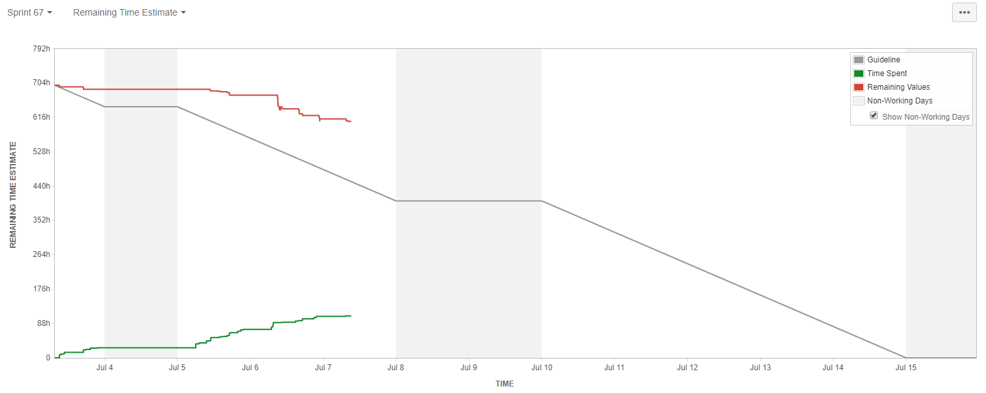

Development Velocity Summary – Last 5 Sprints
Sprint and Start Date | Sprint Items | Sprint Backlog Total Time (hours)  Initial + Changes | Scope Changes  (hours) | Sprint Velocity  Time (hours) Completed | Time (hours)  Unfinished
Sprint 67, 07/03/17 | 48 | 699 | 8 | 80 | 619
Sprint 66, 06/19/17 | 68 | 979 | 100 | 651 | 328
Sprint 65, 06/05/17 | 61 | 720 | 120 | 324 | 276
Sprint 64, 05/22/17 | 69 | 656 | 10 | 200 | 446
Sprint 63, 05/08/17 | 80 | 680 | 50 | 369 | 261
Note: Negative scope hours are reflective of items taken from the sprint over a two week period (sprint start and end).

Key Accomplishments (across the project)
Category | Key Accomplishments and Plans
Requirements | - Access Management Center (AMC)  - Performed testing of AMC functionality on Production server.  Unit tested password statuses using AMC and Active Directory.
System Development & Maintenance | - Server Upgrade  - Performed necessary database changes for new AMC Account Status functionality.  - Supported configuration of BioSense reports on new server.  - Monitored SQL data management and data flow.  - Migrated the Production server to the new Virtual Private Cloud (VPC).  - Set-up testing of linked server connection between NEW ARCHIVE and NEW SNC-INGEST to investigate Insert_All_Site_Essence failed jobs.  - ESSENCE  - Completed Cut-Over copy of ESSENCE Tables.  - Updated GAP raw records and moved to Processed tables.  - Active Directory  - Initiated development of user story “As a Super/Site Admin I want to be able to see AD Password Status”.  - Access Management Center (AMC)  - Performed testing of AMC after migration from Staging to Production.  - SAS Studio Pro  - Initiated installation/configuration of SAS 0.4 on new servers.
Data Onboarding | - New Sites  - Submitted draft New Sit Onboarding Window schedule to team for review.  - Communicated Staging upgrade plans with sensitive sites and solicited feedback for planning activities.  - Performed planned onboarding that was missed due to server transition.  - MFT Updates  - Emailed all site administrators and requested Master Facility Table (MFT) updates for Q3 facility onboarding.  - Started MFT Training for new Onboarding Team member.  - Feed Issues  - Investigated exceptions during data processing and proposed a plan of action to reprocess those records.  - Other  - Completed SOP Data Flow diagrams and reviewed them with the requirements team.
Technical Support | - Internal  - Performed vulnerability scanning and installed system patches where necessary during server upgrade.  - Prepared SAS SOP.  - Worked with Analytics and Data Management (ADM) to resolve connection issues through SSMS and SAS EG.
Data Analytics | - Legacy  - Completed Quality Assurance updates for legacy conversions.  - Coordinated with Analytics and Data Management (ADM) on legacy communications.  - Data Quality  - Investigated exceptions to the character limit in certain data fields.  - Performed Quality Assurance on WI data.  - Other  - Worked with DAT on ESSENCE User Query Support.
Training and Communication | - JIRA/Service Desk  - Updated Analytics and Data Management (ADM) dashboard in JIRA with requested changes.  - Created SDA Technical Assist Project in JIRA.  - Finalized pricing structure for JIRA.  - Server Upgrade  - Executed communications plan for server upgrade.  - Created and executed communications plan for Staging upgrade.

Plans for Next Week (across the project)
Category | Key Accomplishments and Plans
Requirements | - Access Management Center (AMC)  - Develop test plan to test AD in Integration environment.  - Update draft requirements for MFT Facility Administration Tool UI.  - Schedule internal calls to review in scope/out scope for MFT FAT UI initial build.
System Development & Maintenance | - Server Upgrade  - Initiate Staging Server Upgrade work.  - Update the Master Profile.  - Update CloudBerry licenses.  - Follow-up on need for BioTerminal licenses to complete BioTerminal upgrade.  - Update HCW and BSI to reflect server migration.  - Monitor and evaluate performance of new server.  - Active Directory (AD)  - Discuss AMC AD and Account Status changes with development team.  - Perform SQL API changes to support AMC AD changes.  - Support Platform AMC AD integration.  - Develop migration plan for moving user information to Active Directory.  - SAS  - Complete SAS 9.4M4 installation.  - Other  - Deploy Weekly BioSense Lights on Report changes.  - Complete applying production indexes.
Data Onboarding | - New Sites  - Update NSSP Onboarding Guide for New Site Onboarding Window 2.  - Develop NSSP Validation Guide for New Site Onboarding Window 2.  - Develop NSSP Onboarding Quarterly Report for Q2 2017.  - Analyze onboarding statistics and send them recommendations for resolving onboarding issues.  - Master Facility Table  - Reprocess records after MFT has been pulled over.  - Begin planning for Q3 MFT updates.  - Other  - Document investigation steps for NSSP Support SOP.  - Support Password-to-Key pair authentication transition efforts.
Technical Support | - Internal  - Create data deletion process for ADM.  - Create instructional document detailing how to add users in SAS.
Data Analytics | - Legacy  - Perform quality assurance and necessary updates for legacy conversion.  - Perform quality assurance and necessary updates for legacy conversion.  - Coordinate communications on legacy conversion to sites.  - Data Quality  - Finish indexing for production tables.  - Perform Quality Assurance on data.  - Other  - Organize agenda for JHU Meeting.  - Coordinate communications with ADM.  - Facilitate Onboarding webinar 3.
Training & Communication | - JIRA/Service Desk  - Improve functionality of ADM dashboard.

New/Significant Project Issues/Risks/Scope Changes for Current Sprint
Type | ID | Description | Mitigation/Action Taken | Status | Owner
Risk | R012 | Amazon infrastructure issues may affect BioSense Platform infrastructure. | Monitor Amazon performance and prioritize and respond to issues as determined by the project team. | Monitor | Mike Coletta
Risk | R013 | The development, testing, and staging environment AMC applications are not independent systems. Existing connections between each may lead to issues when new development is implemented | The team will work to identify a long term solution to separate the applications (AMC & ESSENCE) in each environment. In the short term, they will create and adhere to SOPs and checklists for releasing new builds in each environment | Monitor | Mike Coletta
Risk | R014 | High volume of project and support tasks is limiting resources available for Onboarding | New Onboarding team member has been hired. Team is supporting Onboarding needs as new staff is learning the role. | Monitor | Mike Coletta
Risk | R015 | We need to secure (SSL/Certificates) Active Directory and Ldap. | All critical operations such as encoded password, enable, and disabled accounts cannot be done on an unsecured connection. Will need help from system admin to secure (SSL/Certificates) active directory-ldap on test domain controller. | Monitor/Research | Mike Coletta
Risk | R016 | Server Transition SQL directives unclear. May need to perform MFT fixes/Reprocessing again on the new Archive server | Server Transition SQL directives unclear. May need to perform MFT fixes/Reprocessing again on the new Archive server | Monitor/Research | Mike Coletta

System Maintenance, Updates and Outages
Date(s) Time(s) of Outages/Updates/Patches | Estimated Downtime | Reason | Expected or Unexpected
Wednesday, July 5th, 2017  8:00 AM to 8:00 PM | 12 hrs. | Cut-Over to new Server VPC | Expected
Production ESSENCE Restarts
Week |  | Number of ESSENCE Restarts
07/03/17 – 07/07/17 |  | Restart tool turned off due to server transition.

Requirements Status and Agile Development Activities (Sub-task 2.3.2 & Sub-task 2.3.6)
 | Date | Last Week's Activities | %  Complete | Upcoming Activities
Data Flow | 07/07/2017 | Completed Production Server upgrade | 100% | Initiate Staging Server Upgrade on July 10
Access & Management Center | 07/07/2017 | Tested AMC on new VPC. Functional. | 100% | Initiate planning user stories for future AMC enhancements
Master Facility Table | 07/07/2017 | None. | 50% | Finalize requirements documentation
Reporting | 0/07/2017 | Tested and deployed reports on new VPC. Fixed errors. | 75% | Continuing to work on draft SOP. Finalize new additions in Production.

Community Enhancement Requests
Enhancement Type | Key | Summary | Status | Created | Updated
ESSENCE Support | NTA-989 | ZIP query –Issues creating a ZIP code count of visits in table | Open | 05/17/2017 | 05/10/2017
Improvement | NTA-704 | Non-required fields in DQ report; NTA- 661 | Active | 04/04/2017 | 06/08/2017

Appendix

Status of This Week’s Technical Assistance Requests

In order to monitor the quality of service provided to external users, the BioSense/NSSP IT project team measures the number of technical assistance requests received in a given week against the number of requests resolved. In this chart you can see the breakdown by issue type of the received requests, as well as the status of the requests.

Status of This Week’s Development Requests

In order to track the progress of the sprint, the BioSense/NSSP IT project team measures the number of development tickets created and resolved on a weekly basis, as well as the overall number of open tickets left to be resolved. In this chart you can see the breakdown by ticket issue type and the status of the tickets.

Development and Technical Assistance Tickets for Current Sprint
The below Chart displays the total number of tickets created this week for the functional development of the current sprint. The chart breaks down the tickets based on the Priority Rubric they were created under.

Status of This Week’s Onboarding Requests

In order to monitor the onboarding progress of new sites, the BioSense/NSSP IT project team measures the number of onboarding tickets created and resolved on a weekly basis, as well as the overall number of open tickets left to be resolved. This information allows the project team to quickly analyze pain points and work to resolve them.

Chart Glossary
Term | Definition
Technical Assistance JIRA Ticket Types
Feat. /Func. Suggestion | A feature or functionality suggested by users/stakeholders.
Onboarding | An onboarding-related technical item.
Processing | A request/item that relates to data processing.
Questions | Any questions for the technical assistance team, e.g. HL7 mapping guide.
Tech. Issue - Backend | A technical issue with the backend of the BioSense system.
Tech. Issue - Frontend | A technical issue with the frontend of the BioSense system.
User Accnt/Access | A user account or access request, e.g. R Studio access.
Other | Other technical requests, e.g. request for new certificates.
Development JIRA Ticket Types
Task/Sub-Task | A development-related issue or request.
Improvement | A suggested change to the system.
New Feature/Function | A suggested new feature to the system.
Bug | A development-related issue or defect.
Status
Open | The item/ticket is in queue.
Active | The item/ticket is in progress.
Inactive | Work on the item/ticket has started, but is on hold for a particular reason.
Waiting for Customer/Support | The item/ticket is being worked on and is waiting on a reply from the customer or support.
Resolved | The item/ticket is done, but needs to be reviewed.
Complete | The item/ticket is done and has been reviewed.
Re-opened | After being resolved or complete, the ticket is re-opened for a particular reason.
Priority Rubric | The development and technical assistance tickets grouped by BioSense Platform functional area
Other Items
BTA | BioSense Technical Assistance. Item/tickets related to technical assistance and coming through the Help Desk.
BA | BioSense Agile. Items/tickets related to development or feature requests or backlog.
Agile | Software development methodology to create requirements and solutions.

