NSSP Weekly Report

NSSP Week Ending 06/30/2017 POC: Alan Davis

NSSP Items This Week

The NSSP IT project operates with two primary sub-projects for tracking purposes: (1) Development and (2) Technical Assistance. The Onboarding project is a sub-project of Technical Assistance. A glossary of chart terms can be found in the next section.

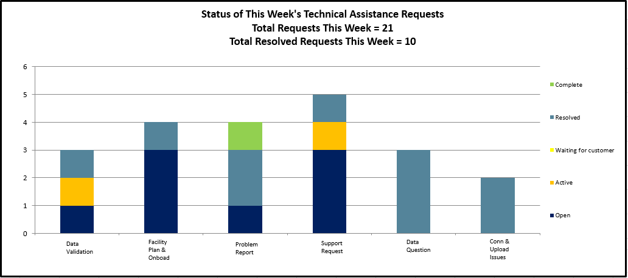

Chart Glossary
Term | Definition
Technical Assistance JIRA Ticket Types
Feat. /Func. Suggestion | A feature or functionality suggested by users/stakeholders.
Onboarding | An onboarding-related technical item.
Processing | A request/item that relates to data processing.
Questions | Any questions for the technical assistance team, e.g. HL7 mapping guide.
Tech. Issue - Backend | A technical issue with the backend of the BioSense system.
Tech. Issue - Frontend | A technical issue with the frontend of the BioSense system.
User Accnt/Access | A user account or access request, e.g. R Studio access.
Other | Other technical requests, e.g. request for new certificates.
Development JIRA Ticket Types
Task/Sub-Task | A development-related issue or request.
Improvement | A suggested change to the system.
New Feature/Function | A suggested new feature to the system.
Bug | A development-related issue or defect.
Status
Open | The item/ticket is in queue.
Active | The item/ticket is in progress.
Inactive | Work on the item/ticket has started, but is on hold for a particular reason.
Waiting for Customer/Support | The item/ticket is being worked on and is waiting on a reply from the customer or support.
Resolved | The item/ticket is done, but needs to be reviewed.
Complete | The item/ticket is done and has been reviewed.
Re-opened | After being resolved or complete, the ticket is re-opened for a particular reason.
Priority Rubric | The development and technical assistance tickets grouped by BioSense Platform functional area
Other Items
BTA | BioSense Technical Assistance. Item/tickets related to technical assistance and coming through the Help Desk.
BA | BioSense Agile. Items/tickets related to development or feature requests or backlog.
Agile | Software development methodology to create requirements and solutions.

Development Sprint Chart
In order to perform Earned Value Management, the BioSense/NSSP IT project team will begin estimating sprints in hours and not sprint points. Earned value project/performance management (EVPM) is a project management technique for measuring project performance and progress in an objective manner. In this version of a sprint burn down chart the red line going down represents the value earned (work completed against the estimate) and the green line represents the hours worked.
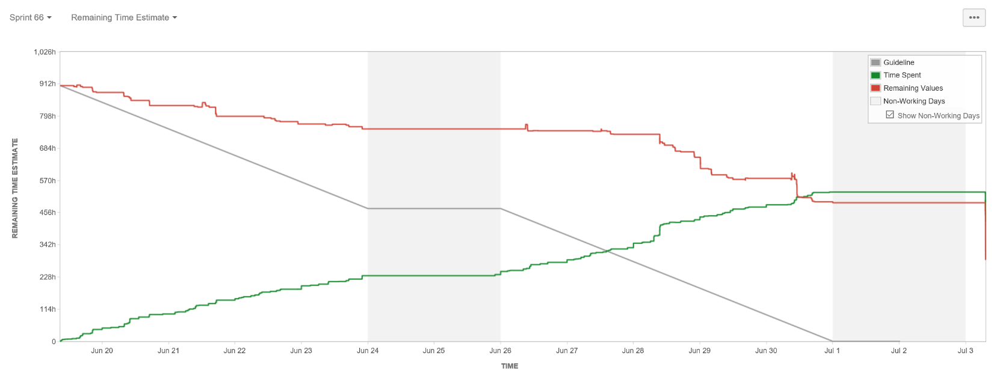

Development Velocity Summary – Last 5 Sprints
Sprint and Start Date | Sprint Items | Sprint Backlog Total Time (hours)  Initial + Changes | Scope Changes  (hours) | Sprint Velocity  Time (hours) Completed | Time (hours)  Unfinished
Sprint 66, 06/19/17 | 80 | 979 | 36 | 651 | 328
Sprint 65, 06/05/17 | 61 | 720 | 120 | 324 | 276
Sprint 64, 05/22/17 | 69 | 656 | 10 | 200 | 446
Sprint 63, 05/08/17 | 80 | 680 | 50 | 369 | 261
Sprint 62, 04/24/17 | 72 | 555 | 70 | 405 | 80
Sprint 61, 04/10/17 | 69 | 630 | -2 | 600 | 30
Note: Negative scope hours are reflective of items taken from the sprint over a two week period (sprint start and end).

Key Accomplishments (across the project)
Category | Key Accomplishments and Plans
Requirements | - Tested AMC User Group functionality in Staging and Production  - Submission of User Group defects in JIRA  - AMC requirement documentation update  - AMC Test Plan update to reflect the User Group functionality  - Tested AMC User Group functionality in Integration  - Updated AMC onboarding presentation and submitted to CDC team.  - Completed call Volumes Report for the month of June to CDC personnel  - June JIRA Development Summary Report to ASTHO group
System Development & Maintenance | - Acquired SAS 9.4.4 software from SAS  - Implemented replication on the New Archive server  - Worked on creating the Link Servers in the new environment using AD accounts in place for the SQL Server logins  - Set up the Link Servers between the servers in the new environment  - Completed access to the new environment by using and additional tunnel in the PUTTY configuration file  - Completed Restart Data processing New Archive to new SNC-Ingest.  - CA legacy conversion QA fixes\updates.  - Added Last_ER_RowID_Updated column to Essence_Process_Log in both NEW ARCHIVE and OLD ARCHIVE for Essence performance tracking.  - Renamed PHINCONV Archive database and copied to transfer drive in preparation for server retirement.  - BA-3563 AMC User Group Defect delete user message was resolved after QA.  - BA-3549 AMC User Group Reset Button was resolved after QA.  - BA-3558 User Group Defect Data Access Allows duplicate groups was resolved after QA.  - BA-3557 User Group Defect checking group filter on main page was resolved after QA.  - BA-3550 Group Defect Checking User Group Filter was resolved after QA.  - Resolved BA-3333 prepare AMC user group for production after production deployment.  - Deployed AMC Test and Stage with enhancements requests  - Discussion on AMC Statuses Issues with database team and Active Directory issues  - Performed Requirement planning for Active Directory  - Deployed AMC Active Directory Integration on integration test  - BA-3565 – Assigned for testing - AMC: As a user, I want to be able to change my AMC password and have it updated throughout BioSense platform
Data Onboarding | - Completed Staging 04/05 Exception reprocessing  - Worked with KS to correct incorrect MSH4.2 segments  - Reached out to VTPorterMedical for investigation (down feed)  - Built tracker that includes critical onboarding in staging for sites  - Sent out communication to get best date for staging server transition dates  - Review Data Investigation SOP Table of Contents with  - Set up a meeting with to discuss MTNorthernMontana Feed  - Review documented the MFT training from  - Downloaded WinSCP, Configure tunnels with  - Given access to phinms and httpd. Walked through a phinms restart with S  - Data Flow SOP Diagram in Visio - SOP Diagram found in Onboarding/_Tim/BioSense Platform  - Implementation of the new NSSP Onboarding Kanban board that improves onboarding scheduling and tracking.  - Removed Solano County from New Site Onboarding Window 1.  - Trained new Onboarding team members on Data Validation.  - Communicated Staging upgrade plans with sensitive sites and solicited feedback for planning activities.  - Assisted NSSP requirements team with NSSP Support SOP document template.  - Started NSSP Onboarding Guide updates for New Site Onboarding Window 2.  - Started NSSP Validation Guide development for New Site Onboarding Window 2.
Data Analytics | - Produced Weekly Legacy Conversion Status One Pager  - Produced Weekly Legacy Conversion Status One Pager, by Site  - Issued meeting notes for the Legacy Weekly Check-In with ADM  - Identified defects discovered during the Legacy conversion process, then coordinated with developers to fix and deploy updated code as well as update damaged records where applicable  - Discovered the logic that caused the Diagnosis Code prepended semicolon defect  - PHINCONV server retirement planning  - Refined the task list based on the feedback  - Refined the diagram based on the feedback  - Oversee SDA tasks and provide feedback  - Christus Health overlapping facilities with Louisiana  - Review data completeness for California Riverside legacy data  - Completed more Legacy conversions (sFTP and PHINMS)  - Kentucky PHINMS data in PHINCONV is approved by the site to move to Production - Processed  - PHINMS sites including Arizona, Colorado NCR, Illinois, Kansas, Nevada, New York State, Tennessee, Wisconsin are currently under SI review  - Confirmed that Christus Health legacy data does not have any duplicative visits or patients with the Louisiana data  - Conducted an assessment of the California Riverside data completeness  - California Nevada site confirmed SFTP legacy conversion requirements  - Planned for PHINCONV server retirement: a copy of the database will be attached to the Production (ARCHIVE server) and DATAMART  - Issued email alerting CDC the sites are available for their review: Kentucky PHINMS  - Completed changes for Weekly Lights on report and submitted for review
Training and Communication | - Assigned unassigned issues resulting in 0 unassigned  - Executed communications plan for server upgrade  - Completed Help Desk SOP draft  - Tested AMC Updates  - Set up SDA project in JIRA

Plans for Next Week (across the project)
Category | Key Accomplishments and Plans
Requirements | - Monthly Status Report  - Weekly Status Report  - AMC and Active Directory Requirements gathering session
System Development & Maintenance | - Prep for SAS 9.4M4 install;  - Continue preparation of SOP for SAS users;  - Create document detailing how to add users to SAS.  - Implementation of the new production environment  - CA legacy conversion QA fixes\updates  - MT legacy conversion QA fixes\updates
Data Onboarding | - Support Production Transition  - Investigate stage-essence flat line issue  - Complete the Data Investigation Flow Chart and create Technical Insights with SD&A team.  - JIRA and ticket items to help the NSSP Onboarding Team  - Understand and/or record walkthrough troubleshoots: Mirth, WinSCP, creating SSH Keys, and MFT  - Develop NSSP Onboarding Quarterly Report for Q2 2017.  - Documentation updates for Onboarding Guide  - Document investigation steps for NSSP Support SOP  - Continue Password-to-Key pair authentication transition efforts.
Technical Support | - Understand and/or record walkthrough troubleshoots: Mirth, WinSCP, creating SSH Keys, and MFT  - Document investigation steps for NSSP Support SOP
Data Analytics | - Work on AMC AD and Account Status changes with development team.  - Work on SQL API changes to support AMC AD changes.  - Deploy Weekly BioSense Lights changes.  - Testing web application access and content on new servers  - Testing new datamart views  - SFTP Legacy QA and communications  - Loading legacy data to new ESSENCE
Training & Communication | - Create Data deletion process for ADM  - Execute on Communications plan  - Continue and iterate upon ADM dashboard

New/Significant Project Issues/Risks/Scope Changes for Current Sprint
Type | ID | Description | Mitigation/Action Taken | Status
Risk | BA-3585 | Set up SAS, BioTerminal Servers – Task Added to sprint | Leave the BioTerminal in the old VPC online until the new one is complete. | Monitor
Risk | R012 | Amazon infrastructure issues may affect BioSense Platform infrastructure. | Monitor Amazon performance and prioritize and respond to issues as determined by the project team. | Monitor
Risk | R013 | The development, testing, and staging environment AMC applications are not independent systems. Existing connections between each may lead to issues when new development is implemented | The team will work to identify a long term solution to separate the applications (AMC & ESSENCE) in each environment. In the short term, they will create and adhere to SOPs and checklists for releasing new builds in each environment | Monitor
Risk | R014 | High volume of project and support tasks is limiting resources available for Onboarding | New Onboarding team member has been hired. Team is supporting Onboarding needs as new staff is learning the role. | Monitor
Risk | R015 | We need to secure (SSL/Certificates) Active Directory and Ldap. | All critical operations such as encoded password, enable, and disabled accounts cannot be done on an unsecured connection. Will need help from system admin to secure (SSL/Certificates) active directory-ldap on test domain controller. | Monitor/Research
Risk | R016 | Server Transition SQL directives unclear. May need to perform MFT fixes/Reprocessing again on the new Archive server | Server Transition SQL directives unclear. May need to perform MFT fixes/Reprocessing again on the new Archive server | Monitor/Research
Risk | R023 | PIV certification issue affecting access to BioSense tools | Work with ITSO on determining new certifications restrictions on PIV | Monitor/Research

System Maintenance, Updates and Outages
Date(s) Time(s) of Outages/Updates/Patches | Estimated Downtime | Reason | Expected or Unexpected
Production ESSENCE Restarts
Week |  | Number of ESSENCE Restarts
06/24/17 – 06/30/17 |  | 12

Requirements Status and Agile Development Activities (Sub-task 2.3.2 & Sub-task 2.3.6)
 | Date | Last Week's Activities | %  Complete | Upcoming Activities
Data Flow | 06/09/2017 | Refined requirements for server upgrade; updated JIRA tickets to assign work | 100% | Execute on the plan and update CDC with developments and progress.
Access & Management Center | 06/29/2017 | Release User Groups end of June: Revised UI and fixed bugs. Tested again with 99% pass.  Planned: AMC Data Sharing Report requirements and ESOOS meeting with Alana | 100% | Deploying to Staging and Production next week.
Master Facility Table | 06/14/2017 | Completed June 21 call with Sophia Crossen to gather feedback on MFT UI. | 50% | Continue updating requirements documentation.
Reporting | 06/16/2017 | Continued working on trigger action SOP. Made cosmetic changes to report. Added new tables to reports in Staging per CDC request. | 75% | Continuing to work on draft SOP. Finalize new additions in Production.

Community Enhancement Requests
Enhancement Type | Key | Summary | Status | Created | Updated
ESSENCE Support | NTA-989 | ZIP query –Issues creating a ZIP code count of visits in table | Open | 05/17/2017 | 05/17/2017
Improvement | NTA-704 | Non-required fields in DQ report; NTA- 661 | Open | 04/04/2017 | 06/08/2017

