NSSP Weekly Report

NSSP Week Ending 01/20/2017 POC: Alan Davis

NSSP Items This Week

The NSSP IT project operates with two primary sub-projects for tracking purposes: Development and Technical Assistance. The Onboarding project is a sub-project of Technical Assistance. A glossary of chart terms can be found in the next section.
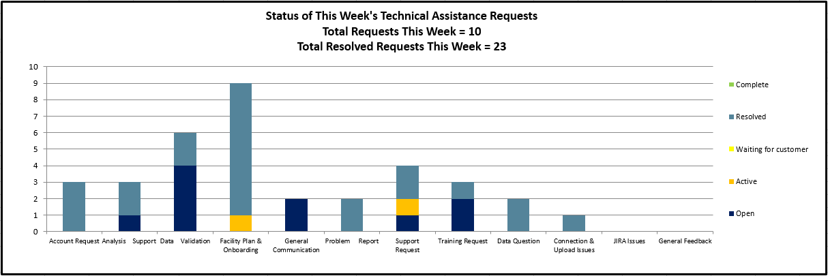
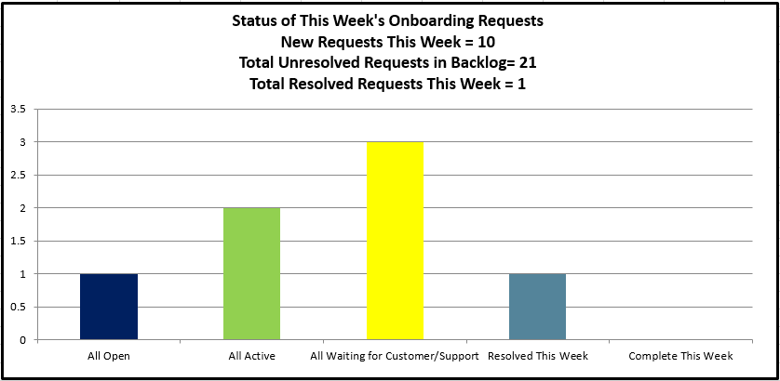
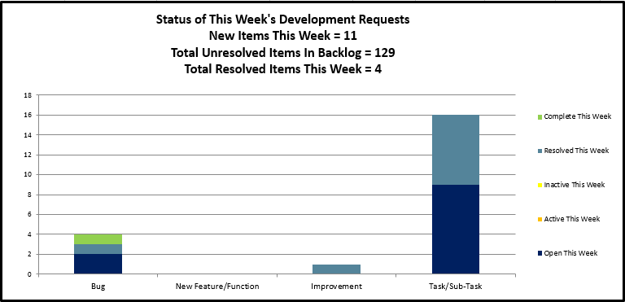

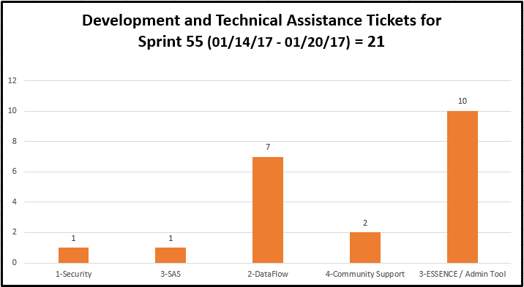

Chart Glossary
Term | Definition
Technical Assistance JIRA Ticket Types
Feat./Func. Suggestion | A feature or functionality suggested by users/stakeholders.
Onboarding | An onboarding-related technical item.
Processing | A request/item that relates to data processing.
Questions | Any questions for the technical assistance team, e.g. HL7 mapping guide.
Tech. Issue - Backend | A technical issue with the backend of the BioSense system.
Tech. Issue - Frontend | A technical issue with the frontend of the BioSense system.
User Accnt/Access | A user account or access request, e.g. R Studio access.
Other | Other technical requests, e.g. request for new certificates.
Development JIRA Ticket Types
Task/Sub-Task | A development-related issue or request.
Improvement | A suggested change to the system.
New Feature/Function | A suggested new feature to the system.
Bug | A development-related issue or defect.
Status
Open | The item/ticket is in queue.
Active | The item/ticket is in progress.
Inactive | Work on the item/ticket has started, but is on hold for a particular reason.
Waiting for Customer/Support | The item/ticket is being worked on and is waiting on a reply from the customer or support.
Resolved | The item/ticket is done, but needs to be reviewed.
Complete | The item/ticket is done and has been reviewed.
Re-opened | After being resolved or complete, the ticket is re-opened for a particular reason.
Priority Rubric | The development and technical assistance tickets grouped by BioSense Platform functional area
Other Items
BTA | BioSense Technical Assistance. Item/tickets related to technical assistance and coming through the Help Desk.
BA | BioSense Agile. Items/tickets related to development or feature requests or backlog.
Agile | Software development methodology to create requirements and solutions.

Development Sprint Chart
In order to perform Earned Value Management, the BioSense/NSSP IT project team will begin estimating sprints in hours and not sprint points. Earned value project/performance management (EVPM) is a project management technique for measuring project performance and progress in an objective manner. In this version of a sprint burn down chart the red line going down represents the value earned (work completed against the estimate) and the green line represents the hours worked.
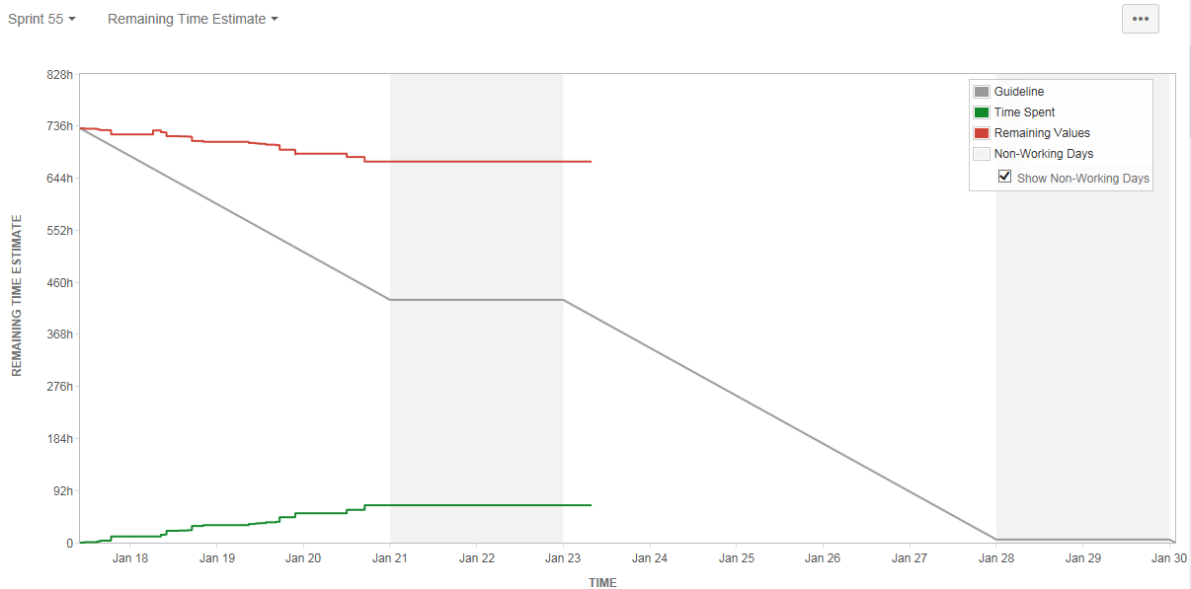

Development Velocity Summary – Last 5 Sprints
Sprint and Start Date | Sprint Items | Sprint Backlog Total Time (hours)  Initial + Changes | Scope Changes  (hours) | Sprint Velocity  Time (hours) Completed | Time (hours)  Unfinished
Sprint 55, 01/17/17 | 61 | 744 | 72 | 92 | 580
Sprint 54, 01/02/17 | 77 | 880 | 260 | 351 | 269
Sprint 53, 12/19/16 | 40 | 520 | 104 | 200 | 216
Sprint 52, 12/05/16 | 61 | 600 | 160 | 380 | 60
Sprint 51, 11/21/16 | 54 | 574 | 55 | 457 | 150

Key Accomplishments and Plans from This Week (across the project)
Category | Key Accomplishments and Plans
Requirements | - Updated/created Jira tickets for data flow enhancements and reprocessing for production AMC  - Completed and distributed the weekly status report 01/13/2017  - Updating Test plan and requirements checklist for January release of the AMC  - Aided with transition communications, technical assistance, and gathered feedback  - Aided in Sprint planning (prioritization and estimation)  - Update the Quick Start Guide for AMC for new AMC release to take place in late January  - Assisted with creating the UI MFT homepage that will be implemented in AMC  - Drafted wireframes for the UI MFT facility information page within the AMC  - Drafted Modal Window Page for Primary Facility Selection for MFT UI page in AMC  - Drafted MFT approval wireframe for Onboarding Super Admins within the AMC  - Currently Testing pages in the Test Plan with regards to the AMC  - Added defect tickets from AMC testing to our Agile application for fixing
System Development & Maintenance | - Worked on code to process DOD  - Address questions regarding legacy data  - Added replication from individual sites from Stage Archive to DataMart  - Monitored SQL environment as a check and balance and look out for anomalies  - Updated AMC design documents  - AMC Test deployment for 1.1.02  - Worked on User Group Characteristics for build in AMC  - Continued to trace issues with datamart_update report;  - Worked at bringing SAS Environment Manager fully up;  - Continued process of evaluation for SAS Studio implementation;  - Received SAS/ACCESS for MS SQL Server to be added to VA Server;  - Participated in meeting with SAS regarding Data Quality;  - Set SQL Server database as repository for SAS DQ.
Data Onboarding | - Resolved Issue with Duplicate Facility Names sending to different FacilityID_UUIDs (in MFT/ESSENCE) –  - Performed regular MFT update requests received in Service Desk  - Continued requirements development/updates for Facility Administration Tool  - Continued preparation for Quarter 1 Onboarding Planning and Prioritization period
Technical Support | - Operational support for the Essence platform  - Monitoring replication objects on the various platforms  - Working on support JIRA tickets  - Working on Biosense Legacy import process
Data Analytics | - Researched UT volume drop for small number of facilities.  - Confirmed ID values being sent for Discharge Disposition met PHIN standards, recommended update to reference tables of valid values being held in ESSENCE for QA Reports.  - QA check Individual sites legacy fixes  - Updated Status (date range, volume) on legacy transition spreadsheet up to Cluster 5  - Worked on updating VET information into the DataMart  - Worked on patches and one off fixes in staging  - Checked indexes on processed and Raw Tables  - Met with ADM team to discuss PHINMS Legacy conversion requirements  - Attended LabCorp data integration requirements  - Reviewed documents related to BioSense Platform from Knowledge Transfer Meetings
Training & Communication | - Updated transition materials  - Monitored and resolved NSSP Mailbox/ Held Desk requests

New/Significant Project Issues/Risks/Scope Changes for Current Sprint
Type | ID | Description | Mitigation/Action Taken | Status
Risk | R012 | Amazon infrastructure issues may affect BioSense Platform infrastructure. | Monitor Amazon performance and prioritize and respond to issues as determined by the project team. | Monitor
Risk | R013 | The development, testing, and staging environment AMC applications are not independent systems. Existing connections between each may lead to issues when new development is implemented | The team will work to identify a long term solution to separate the applications (AMC & ESSENCE) in each environment. In the short term, they will create and adhere to SOPs and checklists for releasing new builds in each environment | Monitor

System Maintenance, Updates and Outages
Date(s) Time(s) of Outages/Updates/Patches | Estimated Downtime | Reason | Expected or Unexpected
Thursday 01/05/17  6:00 AM TO 10:00 AM | 4 hours | Planned Patching – Staging Systems | Expected
Thursday 01/12/17  6:00 AM TO 10:00 AM | 4 hours | Planned Patching – Production Systems | Expected
Monday 1/23/2017  6:00 AM TO 10:00 AM | 4 hours | Planned Patching – Production Systems | Expected

Requirements Status and Agile Development Activities (Sub-task 2.3.2 & Sub-task 2.3.6)
 | Date | Last Week's Activities | %  Complete | Upcoming Activities
Data Flow | 1/09/2016 | The team continued to conduct quality assurance testing on stored procedures, and monitored Production data flow enhancements. | 97% | The requirements team will continue working with development team to streamline transition to the production environment.
ESSENCE Settings | 11/30/2016 | The development team continued testing of multiple account PIV. The project team met to plan an agenda for in-person meeting with JHU. | 96% | The team will meet with JHU to discuss maintenance and remaining development. Key decisions will be documented.
Access & Management Center | 11/30/2016 | AMC Release 1.0.1 was tested to ensure requirements were met. Test plan and results documented and communicated to team for resolution | 97% | The requirements team will conduct testing on the new builds of the AMC and document enhancements/defects as discovered.
Master Facility Table | 11/30/2016 | The team continued development of remaining and changed requirements for MFT updates via Adminer. The project team tested and resolved issues. | 92% | The requirements and data analytics teams will test development and documenting requirement changes as needed.
Reporting | 11/30/2016 | The team added automatic email functionality to the DataMart report, Daily Data Status report and Reporting database. | 88% | The DataMart dashboard report will be implemented and tested. Feedback will be prioritized.

Community Enhancement Requests
Enhancement Type | Key | Summary | Status | Created | Updated
Improvement | REQMTS-446 | AMC – Export/Download Reports | Open | 8/04/2016 | 8/05/2016
Improvement | REQMTS-445 | AMC – Edit Rule Enhancement (Edit data selection) | Open | 8/03/2016 | 8/03/2016
Improvement | BA-2455 | Add Help Desk Link to My Info tab | Resolved | 8/04/2016 | 12/16/2016
Improvement | BA-2288 | Shared space for jurisdiction and workgroups on R-studio | Open | 7/31/2015 | 4/11/2016
Improvement | BA-2496 | User Profile – Make Organization a Required Field | Resolved | 8/04/2016 | 12/16/2016
Improvement | BA-2952 | Remove potential PII columns from AMC User Report | Open | 12/15/2016 | 01/17/2016
New ESSENCE Feature | BA-2288 | ESSENCE Enhancement - Limit Adder/ Configuration Options | Open | 5/23/2016 | 5/23/2016
New ESSENCE Feature | BA-2287 | ESSENCE Enhancement - Trend Alert Lists | Open | 5/23/2016 | 5/23/2016
New ESSENCE Feature | BA-2286 | ESSENCE Enhancement - Add other variables to the % Completeness Data Quality Report | Open | 5/23/2016 | 5/23/2016
New ESSENCE Feature | BA-2285 | ESSENCE Enhancement - Add Data Quality to Report Manager | Open | 5/23/2016 | 5/23/2016

